Use case Overview

Use case Diagram Level 0 : Warehouse and remain product System.

Warehouse and remain product System.

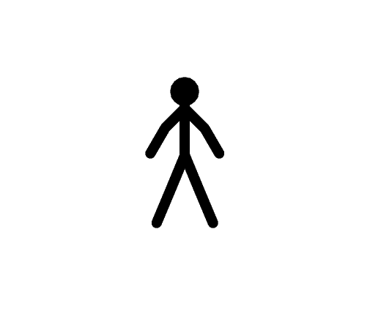

Warehouse Management

WarehouseStaff UJ007



Personal Management

UJ008

Manager



Sale Management

UJ009

Sale employee

Use case Diagram Level 1 : Warehouse Management (UJ007)

Warehouse Management Sub-System

Receive product

UJ017

 Input barcode

Warehouse UJ027

Staff

Out product

UJ037

Use case Diagram Level 2 : Personal Management ( UJ008 )

Personal Management Sub-System

Order Product

UJ028



Manager

Record Income

UJ038

Use case Diagram Level 3 : Sale Management ( UJ009 )

Sale Management Sub-System

Get product

UJ029



Sale employee

Sale Product

UJ039